Lahore Garrison University
DHA Phase 6 Lahore


Student Name | Saud ali
Student Roll No | Fa-2023/BSCS/132
Section | D,E
Subject | Web Technology
Instructor Name | Mr. Muhammad Yousaf

Lab 11: Canvas & SVG — Interactive Graphics
- Objectives:
- Use Canvas API and SVG to draw and animate simple graphics; build a simple drawing app.
- Tools/Tech:
- VS Code, Canvas API, optionally a library (paper.js) — optional
- Tasks/Steps:
1. Create a canvas and draw shapes/text/images via JS.
2. Implement basic user drawing (mouse events) and a clear/save as image feature.
3. Create a simple SVG animation (e.g., moving object).
- Deliverables:
- Drawing app and an example SVG animation; code and demo.
Html Code
<!DOCTYPE html>
<html lang="en">
<head>
<meta charset="UTF-8">
<title>Canvas & SVG Lab — Drawing App</title>
<style>
body {
font-family: Arial, sans-serif;
background: #f3f4f6;
margin: 0;
padding: 20px;
}

.container {
max-width: 900px;
margin: auto;
}

h2 {
text-align: center;
color: #333;
margin-bottom: 20px;
}

.tools {
display: flex;
justify-content: center;
gap: 20px;
margin-bottom: 15px;
}

.tools input[type="color"],
.tools input[type="range"] {
cursor: pointer;
}

canvas {
display: block;
margin: auto;
border: 3px solid #111;
background: white;
box-shadow: 0 0 20px rgba(0,0,0,0.1);
border-radius: 8px;
}

button {
padding: 10px 18px;
background: #111827;
color: white;
border: none;
border-radius: 6px;
cursor: pointer;
font-size: 15px;
transition: 0.3s;
}

button:hover {
background: #2563eb;
}

/* SVG box */
.svg-box {
margin-top: 40px;
padding: 20px;
background: white;
border-radius: 10px;
box-shadow: 0 0 20px rgba(0,0,0,0.08);
}
</style>
</head>
<body>

<div class="container">

<h2>🎨 Canvas Drawing App — Lab 11</h2>

<!-- Tools -->
<div class="tools">
<label>Color: <input type="color" id="colorPicker" value="#000000"></label>

<label>Brush Size:
<input type="range" id="brushSize" min="2" max="50" value="5">
</label>

<button id="clearBtn">Clear</button>
<button id="saveBtn">Save Image</button>
</div>

<!-- Canvas -->
<canvas id="drawCanvas" width="800" height="500"></canvas>

<!-- SVG Animation -->
<div class="svg-box">
<h2>🚀 Sample SVG Animation</h2>

<svg width="800" height="120">
<circle cx="50" cy="60" r="25" fill="#2563eb">
<animate attributeName="cx"
from="50" to="750"
dur="4s"
repeatCount="indefinite" />
</circle>
</svg>
</div>

</div>

<script>
const canvas = document.getElementById("drawCanvas");
const ctx = canvas.getContext("2d");

let drawing = false;

function startDraw(e) {
drawing = true;
draw(e);
}

function endDraw() {
drawing = false;
ctx.beginPath();
}

function draw(e) {
if (!drawing) return;

ctx.lineWidth = document.getElementById("brushSize").value;
ctx.strokeStyle = document.getElementById("colorPicker").value;
ctx.lineCap = "round";

ctx.lineTo(e.offsetX, e.offsetY);
ctx.stroke();
ctx.beginPath();
ctx.moveTo(e.offsetX, e.offsetY);
}

// Event Listeners
canvas.addEventListener("mousedown", startDraw);
canvas.addEventListener("mouseup", endDraw);
canvas.addEventListener("mousemove", draw);
canvas.addEventListener("mouseleave", endDraw);

// Clear button
document.getElementById("clearBtn").addEventListener("click", () => {
ctx.clearRect(0, 0, canvas.width, canvas.height);
});

// Save button
document.getElementById("saveBtn").addEventListener("click", () => {
const link = document.createElement('a');
link.download = "my_drawing.png";
link.href = canvas.toDataURL();
link.click();
});
</script>
</body>
</html>

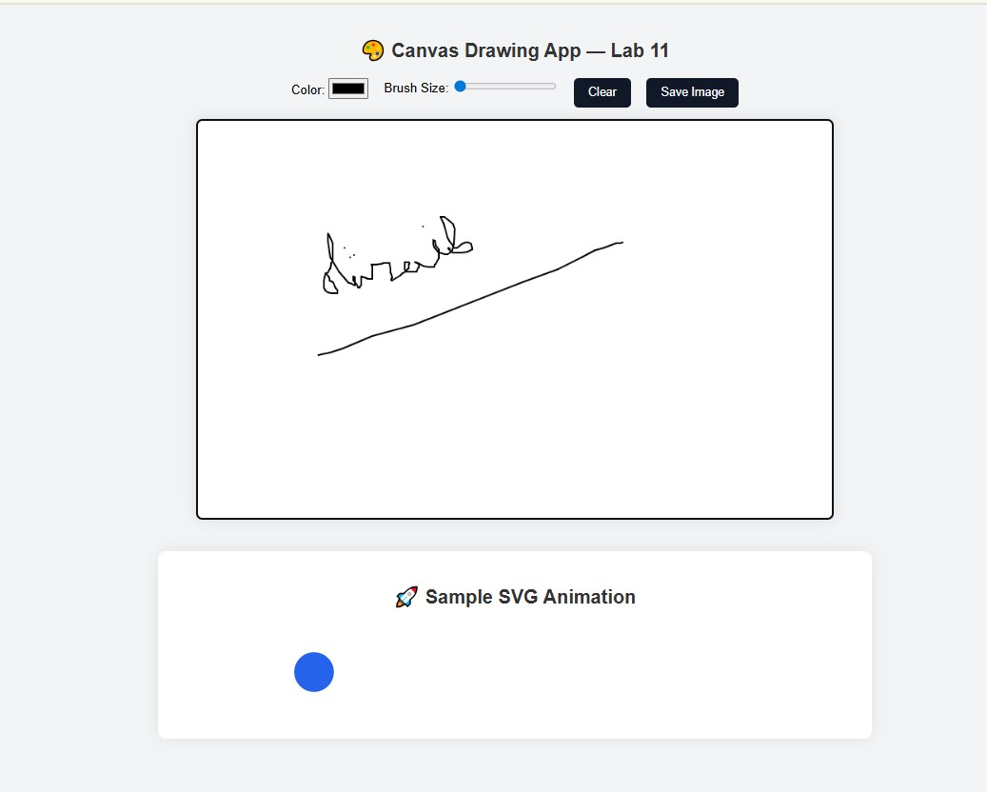

CONCLUSION:
In this lab, we successfully learned how to create interactive graphics using both Canvas and SVG. We implemented a functional drawing application using the Canvas API with custom tools such as color selection, brush size adjustment, clear, and save features. Additionally, we created a simple SVG animation to understand how vector graphics can be animated with ease. Overall, the lab helped build a strong understanding of dynamic graphics, user interaction, and animation on the web.
RUBRICS:
Performance |  |  | Lab Report
Description | Total Marks | Marks Obtained | Description | Total Marks | Marks  Obtained
Ability to Conduct practical | 5 |  | Structure | 5
Data Analysis & Interpretation | 5 |  | Efficiency | 5
Total Marks obtained |  |  | Total Marks Obtained

Instructor Signature

